SCOTI
A Device for Confirmation of Endotracheal Intubation

Operators Manual

TABLE OF CONTENTS
Section Page
1. INTRODUCTION 2
2. SINGLE PATIENT USE SOUND CIRCUIT 2
3. SET-UP & OPERATION 2
3.1. Set-Up 2
3.2. Calibration Procedure 3
3.3. Sensitivity Test 4
4. INTUBATION PROCEDURE 4
5. CLEANING & MAINTENANCE 5
6. BATTERY 5
7. SPECIFICATIONS 6
8. REPLACEMENT PARTS 6
9. TROUBLE SHOOTING 6

INTRODUCTION
Unrecognized and inadvertent esophageal intubation can result in gastric insufflation and lack of oxygen. SCOTI (Sonomatic Confirmation Of Tracheal Intubation) is designed for use during endotracheal intubation, to indicate whether the endotracheal tube is in the trachea or esophagus.
SCOTI is a small battery operated electronic device with multiple visual and audible feedback displays. It is suitable for use in both adults and children. It is attached to the proximal end of the endotracheal tube and can be used with a stylet in place. It continuously analyses the acoustic properties of the air column just beyond its distal end. It is a blocked tube sensor – differentiating between the esophagus, which is soft and collapsible, and the trachea, which is rigid and open. Working by sound, it continuously provides feedback, during the real-time of the intubation procedure, about the position of the endotracheal tube tip, telling the user if the tip is correctly placed in the trachea, or is inadvertently in the esophagus..
An easy way to familiarize yourself with the operation of SCOTI is to visit the web page at www.scoti2.com and go to the computer model. It is also useful to read the most current explanations on the web page.
WARNING: SCOTI can only be used with esophageal tubes having a 5 mm, or larger, inside diameter.

SINGLE PATIENT USE SOUND CIRCUIT
SCOTI does not come in direct contact with the patient, so only appropriate cleaning procedures are required. (See 5 CLEANING and MAINTENANCE) The hardware used to connect SCOTI to the endotracheal tube is referred to as the sound circuit. The sound circuit contains a bacteria filter, (to prevent cross contamination), a flexible tube and a swivel to connect to the endotracheal tube. The swivel adapter has a soft rubber cap to allow a stylet to be inserted into the tracheal.
Figure 1 – Sound Path

SET-UP & OPERATION

Set-Up
  - Attach the bacteria filter end, of the sound circuit to SCOTI.
  - Carefully open the sterile pack containing the selected endotracheal tube and attach the tube to the elbow adapter. Leave the sterile pack on the endotracheal tube.
  - If a stylet is required, swab the rubber cap of the swivel elbow, with alcohol. Puncture the rubber cap by inserting the sterile sylet. Push it through so that it goes almost to the end of the endotracheal tube. Bend the tube as desired. To insure maximum sensitivity, it is best if the stylet has an outside diameter less than 60% of the endotracheal tube size. For instance, a #10 French works well with a 7.0 mm tube and a #14 French works well with a 8.0 mm or larger endotracheal tube.
NOTE: If sterility is desired it can be maintained by keeping the patient end of the endotracheal tube within the tube packaging. (See Figure 2)

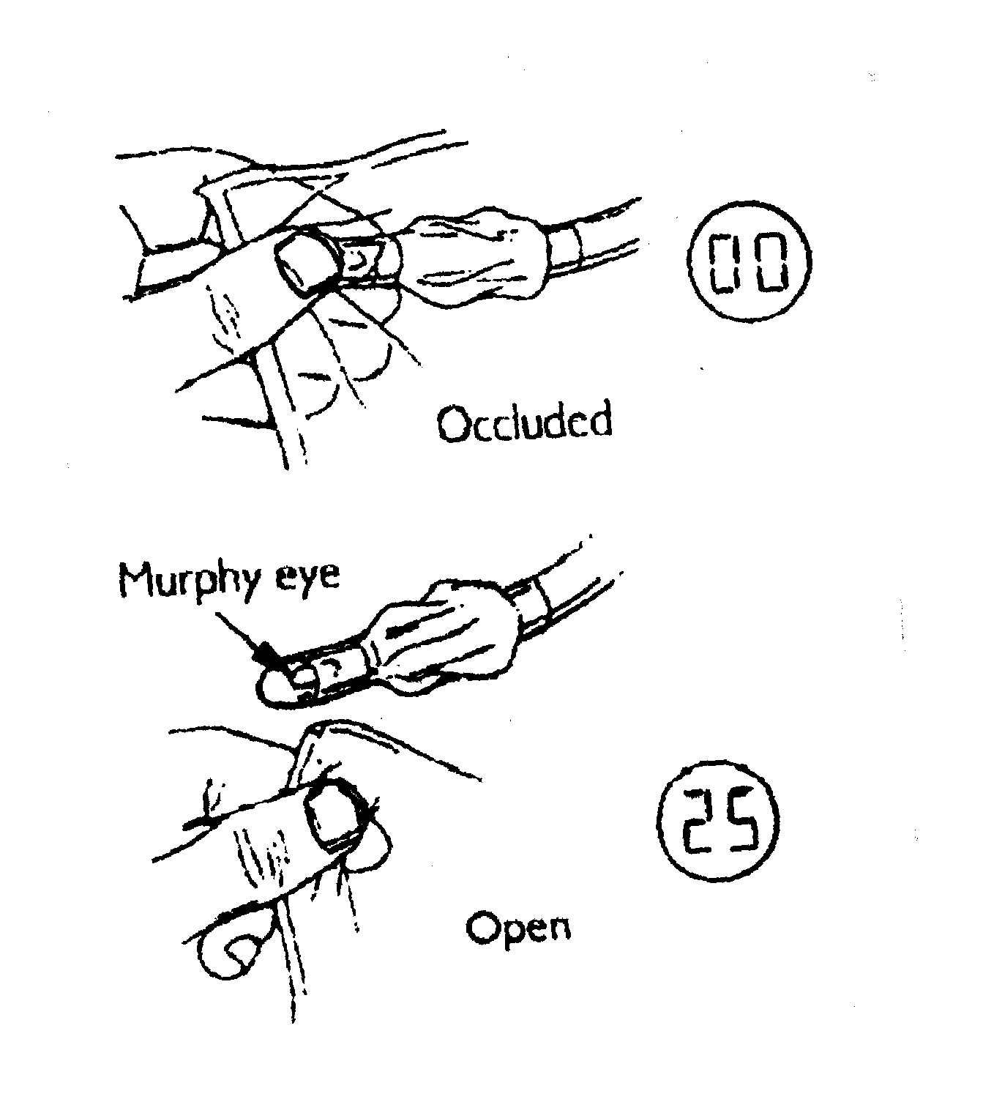
Calibration Procedure
  - Tightly and completely occlude the patient end of the endotracheal tube with two fingers. (This can be done, if desired, with the tube still in its sterile pack.) Turn SCOTI “ON” by depressing the front keypad. SCOTI will take a few seconds to self-calibrate. While doing so it is essential that the fingers continue to occlude the end of the endotracheal tube. If the hole at the end of the endotracheal tube is not completely covered, or if one of the connectors is not attached securely, SCOTI will not calibrate correctly. If a Murphy eye is present, this should also be tightly and completely occluded. ( Figure 2)
Figure 2
  - ESSENTIAL! While calibrating, the fingers must occlude the end of the endotracheal tube until the LCD screen reads ZERO. If the hole at the end of the endotracheal tube is not completely covered, or if one of the connectors is not attached securely, SCOTI will not calibrate correctly. If a Murphy eye is present, this should also be tightly and completely occluded. (See Figure 2)
  - SCOTI is equipped with LED and LCD displays and an audible indicator/alarm. (See Table 1)
  - During the calibration process, the LED will rapidly flash between RED and GREEN. The LCD will display random characters which represent the calibration process and are not significant to the end user.
  - After a few seconds of the calibration process, the LED will display a RED color, the LCD digital readout should show 00 or 01 and the audible alarm will emit a low pitch, beeping. (See Figure 2) Remove the fingers within 3 seconds (or the unit will shut off) and the LED will turn GREEN, completing the calibration process. If this does not occur, See 9 TROUBLE SHOOTING. To recalibrate, briefly turn SCOTI OFF and repeat the calibration procedure.
NOTE: SCOTI will shut off if not properly calibrated. See 9 TROUBLE SHOOTING

Sensitivity Test
Withdraw the tip of the endotracheal tube from its sterile wrapper and check that, with the tube exposed to open air:
  - SCOTI emits a continuous, high pitched tone and
  - The LED is GREEN and
  - The LCD reads 22 or higher.
WARNING: If after repeated attempts, SCOTI fails to calibrate to 00 or 01 and to indicate a reading of 22 or higher during the sensitivity test: DO NOT USE THE DEVICE TO CONFIRM ENDOTRACHEAL INTUBATION.
WARNING: DO NOT stretch the flexible tubing after calibration. Stretching can cause potentially erroneous readings on the LCD display.
WARNING: DO NOT attempt to calibrate SCOTI if there is visible moisture in the sound circuit.

INTUBATION PROCEDURE

Table 1: Intubation Indicator Guide

LED Color | LCD reading | Audible Indicator | Intubation Condition
GREEN | 20-99 | High-pitch continuous | Trachea
ORANGE | 16-19 | Mid-range beeping | Indeterminate
RED | 00-15 | Low pitch beeping | Esophagus

  - Locate SCOTI near the patient’s head. Insert the endotracheal tube in the normal manner. If a stylet is used the stylet must remain in place through the intubation confirmation. As the tube is inserted SCOTI will always start out with the LED GREEN with a high-pitch continuous tone. As it is inserted further SCOTI may change to a RED LED and a low pitch beeping tone. If this occurs it indicates that the endotracheal tube has entered the esophagus and the endotracheal tube should be withdrawn until SCOTI returns to the LED GREEN high-pitch continuous tone condition. Then, the tube should be inserted further but in a slightly different position. Repeat this process until the endotracheal tube is inserted to its normal depth and the LED is GREEN with a high-pitch continuous tone.
  - WARNING: If the lumen of the endotracheal tube becomes blocked with secretions or mucous the LED will become RED with low pitch beeping and will not return to GREEN as you withdraw the endotracheal tube. Once the endotracheal tube is removed from the patient’s mouth the blockage can be removed, the LED will turn GREEN and the intubation can be attempted again.
    - If the trachea is successfully intubated:
            - The LED will be GREEN and
            - The LCD digital readout will be 20 or higher and
            - SCOTI will emit a high pitched, continuous tone.
    - If the esophagus is intubated:
            - The LED will be RED and
            - The LCD digital readout will be 15 or lower and
            - SCOTI will emit a low-pitched beep.
In this case, withdraw endotracheal tube until the LED turns green and repeat the intubation
    - If the intubation is indeterminate:
            - The LED will be ORANGE and
            - The LCD digital readout will be 16 – 19 and
            - SCOTI will emit a mid range beep.
In this case, either withdraw endotracheal tube until the LED turns green and repeat the intubation or use other methods to verify.
  - Should SCOTI be accidentally turned OFF during intubation, disconnect, leaving the endotracheal tube in place. If there is doubt, with regard to the correct placement of the endotracheal tube, SCOTI should be recalibrated using an endotracheal tube exactly the same as the one in use.
  - When SCOTI has confirmed that endotracheal intubation has been successful, disconnect the sound circuit from the endotracheal tube and connect the breathing system in the usual manner.
  - To turn SCOTI OFF, briefly press the ON/OFF pad.

CLEANING & MAINTENANCE
  - For inquiries regarding servicing or repair of your SCOTI or any problems not described in this manual, contact the manufacturer’s Service Department. SCOTI contains no internal, user serviceable components. Attempting to open the unit will void the warranty
  - SCOTI can be cleaned by wiping the exterior with a cloth.

BATTERY
  - Changing the battery --SCOTI is supplied with a 9 volt alkaline battery. To replace the battery simply open the plastic door on the back of SCOTI.
  - Battery Life – The battery will provide up to seven hours of continuous use.
  - Low Battery – SCOTI is equipped with a low battery indicator. When the battery charge is low, the LED will flash, so that the LED is “ON” for only 50% of the time. A decimal point will also be visible between the digits. The readings are still reliable in this state and the intubation can be completed with confidence. The battery should be changed immediately upon completion of the intubation.
  - Replace Battery – If the battery charge is very low, the LED and the alarm become disabled, while the digital display will continue to operate. In this case, the reading from SCOTI should not be considered reliable and the battery replaced immediately.
CAUTION: Remove the battery during storage – a leaking battery can be corrosive.
WARNING: Used or defective batteries contain corrosive and toxic material. Dispose according to local ordinances.

SPECIFICATIONS

Height: 6.8 inches
Width: 3.2 inches
Depth: 2.5 inches
Weight: 0.75 pounds

Output Sound Frequency: 281 – 900 HZ
Sound Power: < 200 mW
Battery: 9 volt Alkaline
Input Current: 45 mA

REPLACEMENT PARTS

SCOTI, complete

Single Patient Use Sound Circuit

Operators Manual

TROUBLE SHOOTING

Symptom | Possible cause
No function  Visible decimal point | No or low battery, See 6 BATTERY
Unit shuts – off | Unit not properly calibrated, See 3.1 CALIBRATION PROCEDURE
Will not calibrate | - Failure to maintain a tight occlusion of the tip of the endotracheal tube (and Murphy eye, if used) during calibration.  - An air leak at a connector in the sound pathway, or hole in tubing.  - Sound pathway incorrect.  a. Flexible tubing too long, too short or incorrect inside diameter.  b. Inside diameter of endotracheal tube is too small.  c. Diameter of stylet is too large for endotracheal tube.  d. Bacterial filter has excessive acoustical impedance.

